Solutions :

1. Ans : (c)

$r=$ distance between (1,2) and (4,6)

$=5$

$∴ A=πr^{2}=25π$

1. Ans : (c)

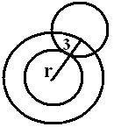Centre of given circle $=\left(-\frac{3}{2} , 3\right) , r=\sqrt{\frac{9}{4}+9+9}=\frac{9}{2}$

Required locus is the circle with centre $\left(-\frac{3}{2} , 3\right)$ and $r=3+\frac{9}{2}=\frac{15}{2}$

Required circle is ${\left(x+\frac{3}{2}\right)}^{2}+{(y-3)}^{2}=\frac{225}{4}$

1. Ans : (b)

$x^{2}+y^{2}-x+2y+\frac{k}{7}=0$

$πr^{2}=12π ⇒ r^{2}=12 ⇒ g^{2}+f^{2}-c=12 ⇒ \frac{1}{4}+1-\frac{k}{7}=12 ⇒ k=-\frac{301}{4}$

1. Ans : (d)

Centres $A=\left(1,2\right), B=\left(6,8\right), r_{1}=2, r_{2}=3$

$AB=\sqrt{61} , r_{1}+r_{2}=5 , AB>r_{1}+r_{2}$

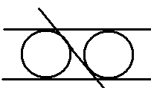

1. Ans : (b)

As two of the 3 lines are parallel the number of possible circles is 2

1. Ans : (b)

As $f^{2}=g^{2}=c=9$ the coordinate axes are tangents and their combined equation is $xy=0$

1. Ans : (d)

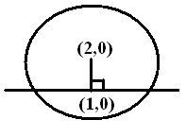Centre $=(2,0)$, mid point $=(1,0)$

Line joining them is $y=0$

$∴$ The chord is perpendicular to any horizontal line

1. Ans : (d)

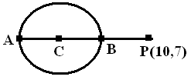Centre $C=\left(2,1\right), r=5,CP=10$

Least distance $=PB=CP-r=5$

Greatest distance $=PA=CP+r=15$

1. 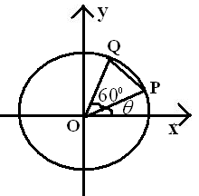Ans : (a)

Let 

$∴$

$∴ ∆OPQ$ is equilateral

$∴ PQ=r=4$

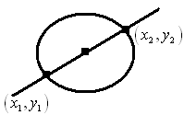

1. Ans : (c)

Let $\left(x_{1},y_{1}\right)=\left(3,4\right), \left(x_{2},y_{2}\right)=\left(-1,-2\right)$

Equation of the circle is $\left(x-x_{1}\right)\left(x-x_{2}\right)+\left(y-y_{1}\right)\left(y-y_{2}\right)=0$

1. Ans : (b)

Any tangent is of the form $y=mx+\frac{a}{m}$

Where $m=\tan{\frac{π}{3}}=\sqrt{3} , a=3$

1. Ans : (d)

Consider the latus rectum in particular : S is the focus

$∴ \frac{1}{SP}+\frac{1}{SQ}=\frac{1}{2a}+\frac{1}{2a}=\frac{1}{a}$

1. Ans : (a)

$x=2+2t^{2} ⇒ t^{2}=\frac{x-2}{2} ; y=4t+1 ⇒ t=\frac{y-1}{4}$

$t^{2}=\frac{x-2}{2}=\frac{{(y-1)}^{2}}{16} ⇒ {(y-1)}^{2}=8(x-2)$

Vertex is (2,1) focus is $(a+h,k)=(4,1)$

1. Ans : (d)

Here $a=1, y=mx+\frac{1}{m}$ is a tangent (1,3) lies on it

$⇒ 3=m+\frac{1}{m} ⇒ m^{2}-3m+1=0 ⇒ m_{1}+m_{2}=3 , m_{1}m_{2}=1$

$\tan{θ}=\left|\frac{m_{1}-m_{2}}{1+m_{1}m_{2}}\right|=\left|\frac{\sqrt{{(m_{1}+m_{2})}^{2}-4m_{1}m_{2}}}{1+m_{1}m_{2}}\right|=\frac{\sqrt{5}}{2}$

1. Ans : (c)

$O=\left(0,0\right), L=\left(a,2a\right), L^{'}=(a,-2a)$

Area of $∆OLL^{'}=\frac{1}{2}\left\{O+a+\left(-2a\right)+a\left(-2a\right)\right\}=-\frac{4a^{2}}{2}$

$∴$ Area $=2a^{2}=72 ⇒ a=6$

$∴$ directrix : $x=-6$

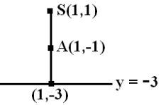

1. Ans : (a)

Vertex is mid point between focus and directrix

1. Ans : (c)

The two parabolas intersect at (0,0) and (4a,4a) and the length of the common chord is the distance between them.

Required $=\sqrt{16a^{2}+16a^{2}}=4\sqrt{2}a$

1. Ans : (b)

Focal distance of $P=PS=x+a$

Here $a=1, x+1=17 ⇒ x=16 ⇒ y^{2}=64 ⇒ y=±8$

Points are $(16,8) or (16,-8)$

1. Ans : (a)

$x^{2}-4x-8y+12=0 ⇒ {(x-2)}^{2}=8(y-1)$

$a=2, h=2, k=1$

Directrix is $y=-a+h=-2+2$

i.e $y=0$

1. Ans : (d)

Here $m=2, c=k, a=2, c=\frac{a}{m} ⇒ c=1$

$∴ k=1$

1. Ans : (c)

$PS=e(PM)$

$here S=\left(0,0\right), e=\frac{1}{2} , PM=\left|x+6\right|$

$\sqrt{x^{2}+y^{2}}=\frac{1}{2}\left|x+6\right|$ on squaring and arranging

$3x^{2}+4y^{2}-12x-36=0$

1. 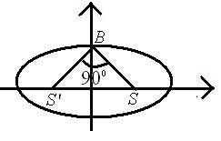Ans : (b)

In triangle OBS, $\tan{45°}=\frac{OB}{OS} ⇒ ae=b ⇒ \frac{b}{a}=e$

$∴$ $e^{2}=1-\frac{b^{2}}{a^{2}} ⇒ e^{2}=1-e^{2} ⇒ 2e^{2}=1 ⇒ e=\frac{1}{\sqrt{2}}$

1. Ans : (d)

$\frac{2b^{2}}{a}=\frac{1}{4}\left(2b\right) ⇒ \frac{b}{a}=\frac{1}{4}$

$∴$ $e=\sqrt{1-\frac{b^{2}}{a^{2}}}=\sqrt{1-\frac{1}{16}}=\frac{\sqrt{15}}{4}$

1. Ans : (c)

Mid point of LR is (3,5) which is the other focus. Distance between the foci $=\sqrt{0+16}=4$

1. 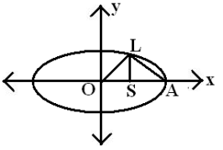Ans : (c)

Triangles OLS & LSA are equal in area

$∴ 2OS=OA$

$⇒ a=2ae ⇒ e=\frac{1}{2} ⇒ \frac{b^{2}}{a^{2}}=1-e^{2}=\frac{3}{4} ⇒ \frac{b}{a}=\frac{\sqrt{3}}{2}$

1. Ans : (c)

$2a=2\left(2b\right) ⇒ a=2b$ and $πab=2π ⇒ ab=2 ⇒ a\left(\frac{a}{2}\right)=2 ⇒ a=2$

$∴$ required sum $=2a=4$

1. Ans : (d)

Let p be any point on the ellipse. Then $PS+PS^{'}=2a SS^{'}=2ae$

Required $=2a+2ae$

Here $a=4, b=3 ∴ e=\frac{\sqrt{a^{2}-b^{2}}}{a} ⇒ ae=\sqrt{a^{2}-b^{2}}=7$

Required $=2\left(4+\sqrt{7}\right)$

1. Ans : (b)

w.k.t focus (ae,0) lies on $x=2y+3 ⇒ ae=3 ⇒ a\left(\frac{3}{4}\right)=3 ⇒ a=4$

$∴ b^{2}=a^{2}-a^{2}e^{2}=16-9=7 , b=\sqrt{7}$

1. Ans : (b)

Required $2a:\frac{2b^{2}}{a}=a^{2}:b^{2}=25:16$

1. Ans : (b)

Area of the triangle is maximum if P coincides with B

Then area of the $∆=\frac{1}{2}∙SS^{'}∙OB=\frac{1}{2}∙2ae∙b=b∙ae=\sqrt{75}∙\sqrt{a^{2}-b^{2}}=5\sqrt{3}\sqrt{25}=25\sqrt{3}$

1. Ans : (b)

$e=\sqrt{2} ,\frac{2a}{e}=16, 2a=16e$

Distance between foci $=2ae=16e^{2}=32$

1. Ans : (c)

Here $a=2, b=\frac{4}{\sqrt{5}} ∴ 2\sec{θ}=3 , \frac{4}{\sqrt{5}}\tan{θ}=2$

Dividing, $\frac{2\sec{θ}}{\frac{4}{\sqrt{5}}\tan{θ}}=\frac{3}{2} ⇒ cosec θ=\frac{3}{\sqrt{5}} ⇒ \cos{θ}=\frac{2}{3}$

1. Ans : (c)

$\frac{x^{2}}{16}-\frac{y^{2}}{\frac{144}{λ}}=1 ⇒ \frac{x^{2}}{16}-\frac{y^{2}}{\left(\frac{-144}{λ}\right)}=1$

$e=\frac{5}{4} , \frac{b^{2}}{a^{2}}=e^{2}-1 ⇒ \frac{\frac{-144}{λ}}{16}=\frac{25}{16}-1 ⇒ λ=-16$

1. Ans : (c)

Vertex is mid point of focus and center

Hence $a=\frac{ae}{2} ⇒ e=2 ; b^{2}=a^{2}e^{2}-a^{2}=3a^{2}$

1. Ans : (c)

$\frac{2b^{2}}{a}=8 ⇒ b^{2}=4a and 2b=\frac{1}{2}\left(2ae\right) ⇒ 2b=ae ⇒ \frac{b}{a}=\frac{e}{2}$

$∴ \frac{b^{2}}{a^{2}}=e^{2}-1 ⇒ 1+\frac{e^{2}}{4}=e^{2} ⇒ \frac{3e^{2}}{4}=1 ⇒ e=\frac{2}{\sqrt{3}}$

1. Ans : (a)

$2ae=16 ⇒ ae=8$ and $e=\sqrt{2} ⇒ a=b=\sqrt{32}$

$⇒$ hyperbola is rectangular

1. Ans : (a)

$\left(±ae,0\right)=\left(±2,0\right) ⇒ ae=2 and e=\frac{3}{2} ⇒ a=\frac{4}{3}$

$b^{2}=a^{2}e^{2}-a^{2}=4-\frac{16}{9}=\frac{20}{9}$

1. Ans : (a)

It is a hyperbola with $(±3,0)$ as the foci and length of the transverse axis = 4

1. Ans : (c)

$\frac{1}{e_{1}^{2}}+\frac{1}{e_{2}^{2}}=1 and e_{1}=e_{2}=e ⇒ e=\sqrt{2}$

1. Ans : (d)

We have $\left(3,0\right) and (3\sqrt{2},2)$ lies on the hyperbola

$\frac{9}{a^{2}}=1 ⇒ a^{2}=9 and\frac{18}{a^{2}}-\frac{4}{b^{2}}=1 ⇒ b^{2}=4$

$e=\sqrt{1+\frac{4}{9}}=\frac{\sqrt{13}}{3}$

1. Ans : (a)

Slope of L.R $=\frac{4-2}{2-4}=-1$, Axis passes through S(3,3) and slope of axis = 1

1. Ans : (c)

${\left(\frac{x}{3}\right)}^{2}+{\left(\frac{y}{4}\right)}^{2}={\left(\cos{t}+\sin{t}\right)}^{2}+{\left(\cos{t}-\sin{t}\right)}^{2}$

$\frac{x^{2}}{9}+\frac{y^{2}}{16}=2 ⇒ \frac{x^{2}}{18}+\frac{y^{2}}{32}=1$

$L.L.R=\frac{2b^{2}}{a}=\frac{2\left(18\right)}{\sqrt{32}}=\frac{2\left(18\right)}{4\sqrt{2}}=\frac{9}{\sqrt{2}}=\frac{9\sqrt{2}}{2}$

1. 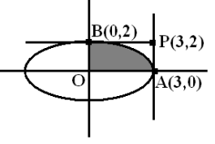Ans : (a)

$\frac{x^{2}}{9}+\frac{y^{2}}{4}=1$

$OAPB$ is a rectangle, area $=3×2=6$

1. 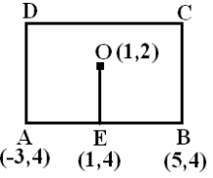Ans : (a)

E = midpoint of AB = (1,4)

BC = 2(OE) = 4

AB = 8

Area $=8×4$

1. Ans : (c)

Verify only $\left(-\frac{2}{5} , -\frac{11}{5}\right)$ lies on $3x-y=1$

1. Ans : (a)

$e_{1}^{2}=1-\frac{b^{2}}{a^{2}} and e_{2}^{2}=1+\frac{b^{2}}{a^{2}}$

$∴ e_{1}^{2}+e_{2}^{2}=2$

1. Ans : (a)

Centre $=\left(1,1\right), r=1$

1. Ans : (a)

Only circle with centre $(1,-2)$ is in option (a)

1. Ans : (c)

$g^{2}=f^{2}=c$ must hold good

1. 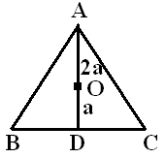Ans : (c)

Centre = Centroid

$\frac{OA}{OD}=\frac{2a}{a} ⇒ OA=2a=radius$

1. Ans : (b)

$x=24, y^{2}=6x ⇒ y=±12$

$P=\left(24,12\right), Q=(24,-12)$

Equation of OP is $=\frac{12}{24}x$, Equation of OQ is $y=-\frac{12}{24}x$

1. 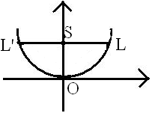Ans : (c)

$L=\left(6,3\right), L^{'}=(-6,3)$

$Area of ∆OLL^{'}=\frac{1}{2}×LL^{'}×OS=\frac{1}{2}×12×3=18$

1. Ans : (a)

Directrix $x=-5$

we have directrix is $x=-a+h ⇒ -a+h=-5 ⇒ -a-3=-5 ⇒ a=2$

1. Ans : (a)

$S=\left(1,-1\right), P(x,y)$ be any point on the ellipse

$\frac{pS}{pM}=\frac{1}{2} ⇒ \sqrt{{(x-1)}^{2}+{(y+1)}^{2}}=\frac{1}{2}\left|\frac{x-y-3}{\sqrt{2}}\right|$

Squaring and arranging we get

1. Ans :(c)

$2a=7$, hyperbola is $\frac{4x^{2}}{49}-\frac{y^{2}}{b^{2}}=1$, passes through $\left(5,-2\right) ⇒ \frac{100}{49}-\frac{4}{b^{2}}=1 ⇒ b^{2}=\frac{196}{51}$

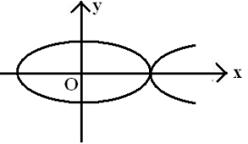

1. Ans : (b)

Vertex (k,0) must coincide with (a,0) i.e., (5,0)

$∴ k=5$

1. Ans : (d)

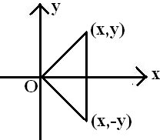 $\sqrt{x^{2}+y^{2}}=\sqrt{4y^{2}} ⇒ x^{2}=3y^{2}$

$x^{2}=12x ⇒ x=12$

Required $=2y=\frac{2x}{\sqrt{3}}=2\left(\frac{12}{\sqrt{3}}\right)=8\sqrt{3}$

1. Ans : (b)

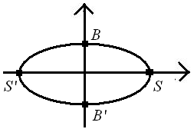 $ae=b ⇒ \frac{b}{a}=e$

$e^{2}=1-\frac{b^{2}}{a^{2}} ⇒ 2e^{2}=1 ⇒ e=\frac{1}{\sqrt{2}}$

1. Ans : (b)

$S_{1}S_{2}=2ae ⇒ 2ae=\sqrt{386}$

$OS_{2}-OS_{1}=2a ⇒ 2a=25-13=12 ⇒ e=\frac{2ae}{2a}=\frac{\sqrt{386}}{12}$

1. Ans : (c)

Area of bigger triangle $=\frac{1}{2}×A'S×LL'$

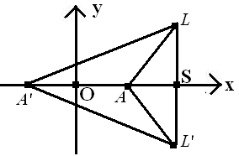 $=\frac{1}{2}\left(a+ae\right)\frac{2b^{2}}{a}=b^{2}\left(1+\sqrt{2}\right) (∵ e=\sqrt{2})$

Area of smaller triangle $=\frac{1}{2}×AS×LL'$

$=\frac{1}{2}\left(ae-a\right)\frac{2b^{2}}{a}=\left(\sqrt{2}-1\right)b^{2}$

Their ratio $\left(\sqrt{2}+1\right):\left(\sqrt{2}-1\right)$

**Answer Key :**

|  |  |  |  |  |  |  |  |  |  |
| --- | --- | --- | --- | --- | --- | --- | --- | --- | --- |
| 1) c | 2) c | 3) b | 4) d | 5) b | 6) b | 7) d | 8) d | 9) a | 10) c |
| 11) b | 12) d | 13) a | 14) d | 15) c | 16) a | 17) c | 18) b | 19) a | 20) d |
| 21) c | 22) b | 23) d | 24) c | 25) c | 26) c | 27) d | 28) b | 29) b | 30) b |
| 31) b | 32) c | 33) c | 34) c | 35) c | 36) a | 37) a | 38) a | 39) c | 40) d |
| 41) a | 42) c | 43) a | 44) a | 45) c | 46) a | 47) a | 48) a | 49) c | 50) c |
| 51) b | 52) c | 53) a | 54) a | 55) c | 56) b | 57) d | 58) b | 59) b | 60) c |